Modern Day Resistances:
The continued battle for Aboriginal Rights and Lands

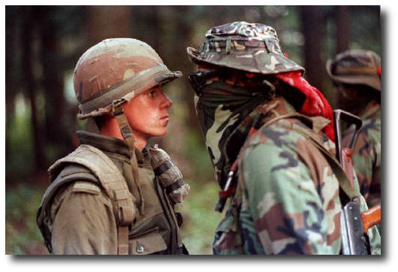
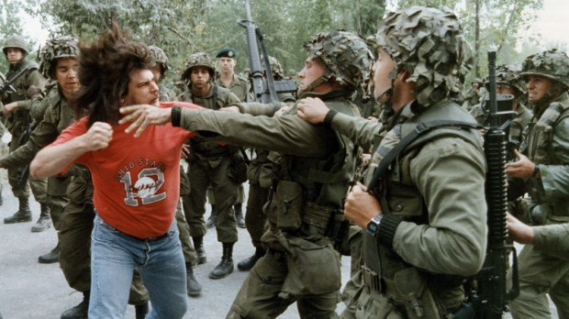

Directions:
- Read and acquire information on one of the provided “modern day resistances”
- Gather information as a group from the handouts and internet
- Organize acquired information on whiteboard or other format
- Present information to the class so students can complete the graphic organizer below

Resistances:
- Oka Crisis
- Ipperwash Crisis
- Battle at Gustafsen Lake
- Penticton Indian Band Apex Blockade
- Idle No More

Resistance + Standoff Videos:
Gustafsen Lake: http://www.cbc.ca/archives/categories/society/native-issues/the-battle-for-aboriginal-treaty-rights/rcmp-and-native-people-stand-off-at-gustafsen-lake.html
Oka: https://www.youtube.com/watch?v=61ldZTjlfgE
Idle No More: https://www.youtube.com/watch?v=IzXI7aznBtc

Provide Who, What, Where, When, Why and How and any other interesting details / info:

